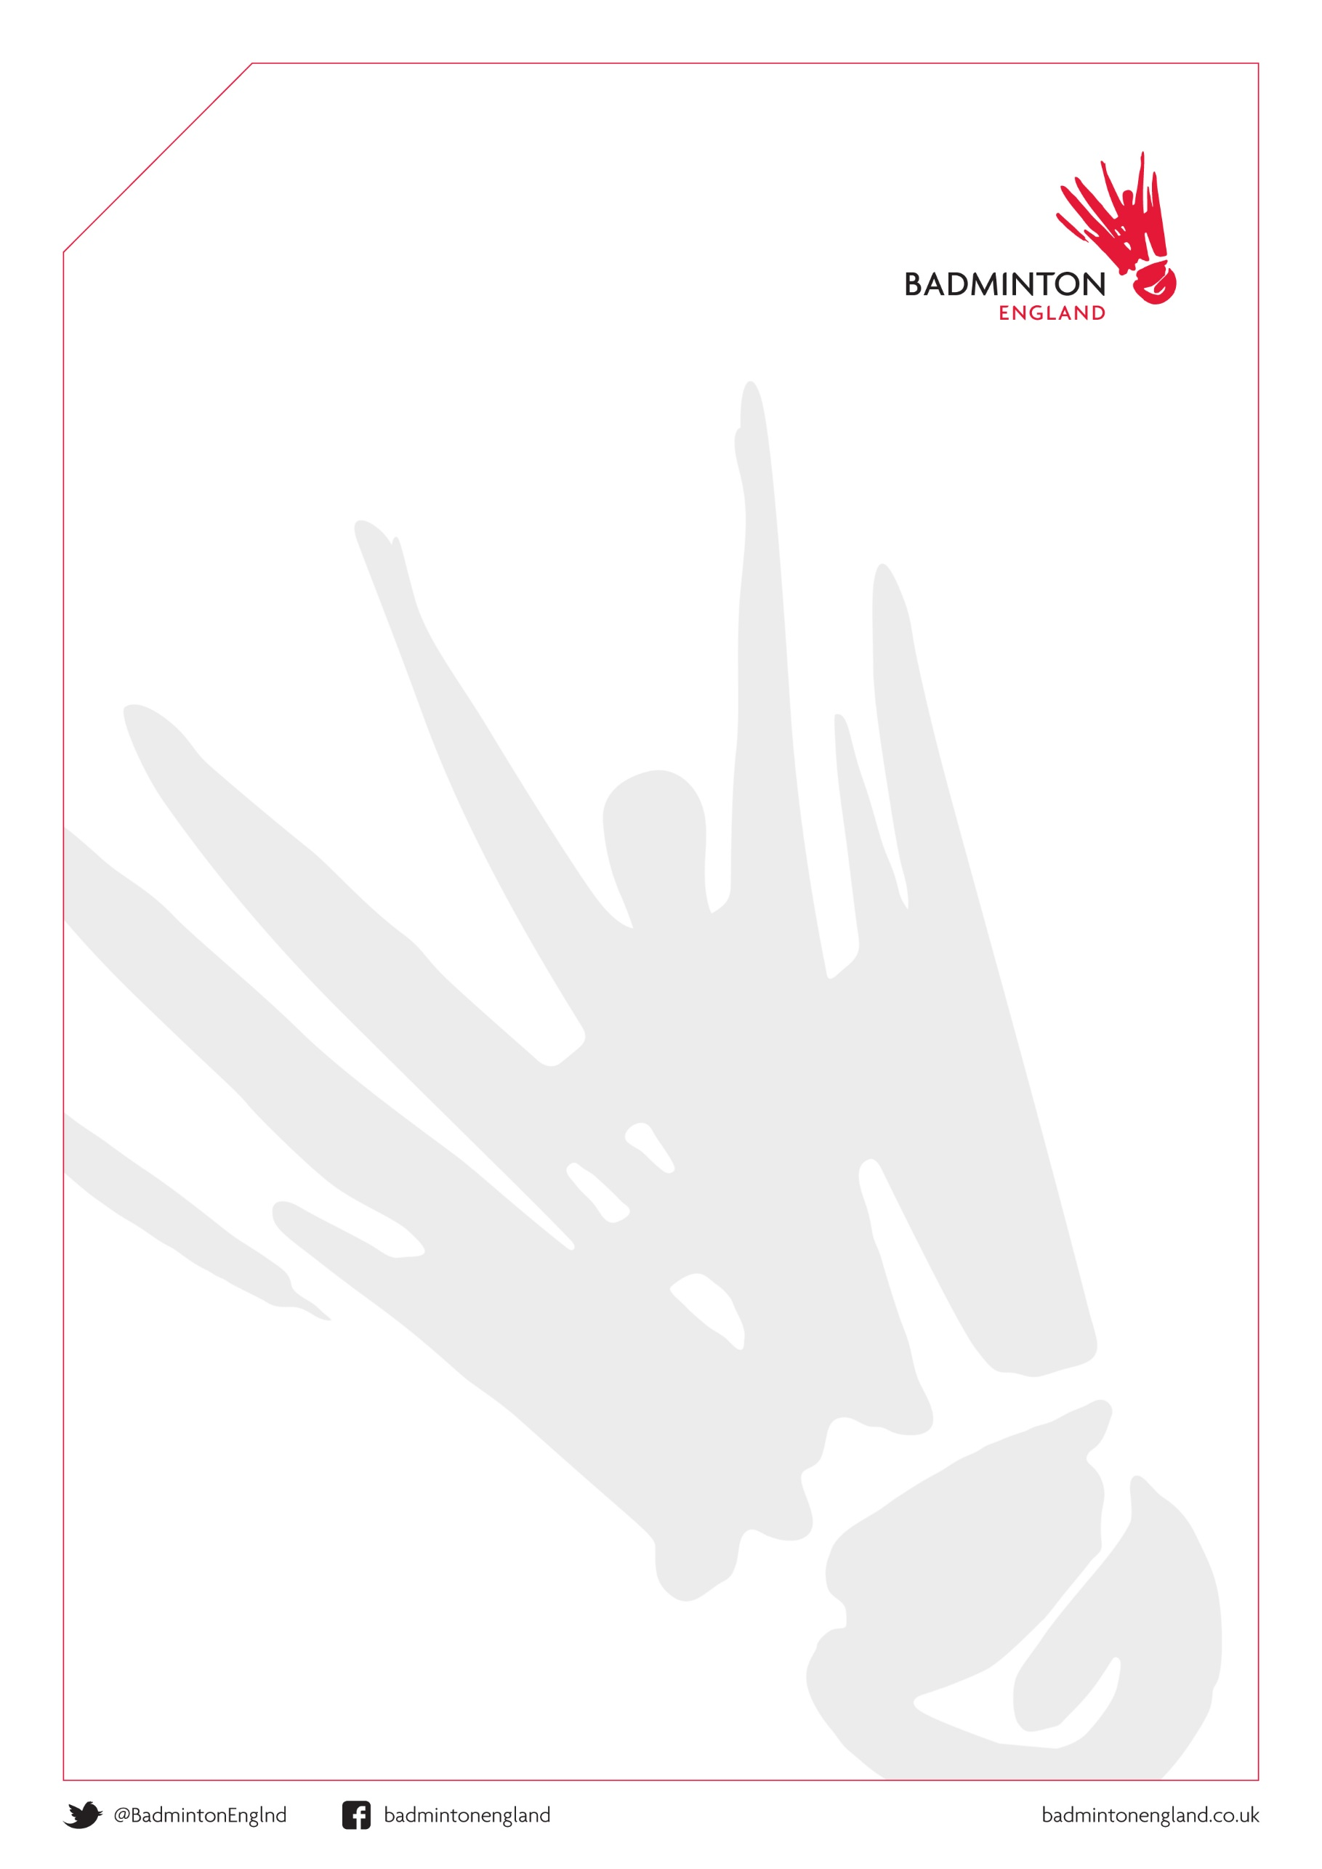


THE 2026/27
MASTERS’ COUNTY CHALLENGE

Saturday 9th & Sunday 10th January 2027

BADMINTON VENUE
University of Worcester Arena
Hylton Rd, Worcester WR2 5JN
Tel No 01905.544444

COMPETING TEAMS:
040 Div 1A | 045 Premier | 055 Premier | 065 Premier | 070 Premier
Buckinghamshire | Derbyshire | Hampshire | E of Scotland | Avon
Lancashire | Essex | Kent | Essex | Hampshire
Leicester | Lancashire | Lancashire | Kent | Lancashire 1
Lincolnshire | Nottinghamshire | Lincolnshire | Lancashire 1 | Leicestershire
Nottinghamshire | Surrey | Surrey | Somerset | Surrey 1
Wales S | Sussex | Wiltshire | Surrey | Yorkshire 1
Wales N & E | Yorkshire | W of Scotland | Yorkshire | Yorkshire 2

ACCOMMODATION / DINNER & DISCO VENUE:
Abbey Hotel, Abbey Rd,
Great Malvern, Worcestershire WR14 3ET
01684 897897

Contact
Natalie Ball 01684 892332
nball@sarova,com

Please complete the hotel booking form below and return direct to the hotel

Accommodation relates to the nights of Friday 8th and Saturday 9th January 2027

RSL SHUTTLES WILL BE USED.



Malvern Hotel Package Information

All deposits and bookings forms must be returned by Monday 10th November 2026 and are non-refundable in the event of cancellation
(ALTHOUGH A NAME CHANGE IS ACCEPTABLE)

Package | Nights | Room Type | Package Detail | Cost Per Person
A | 1 | Double Or Twin | - Accommodation on Saturday  - Banquet & disco on Saturday night  - Breakfast on Sunday Morning | £99.50
B | 1 | Single | - Accommodation on Saturday  - Banquet & disco on Saturday night  - Breakfast on Sunday Morning | £118.00
C | 2 | Double Or Twin | - Buffet style supper on Friday night  - Accommodation on Friday night  - Full English buffet style breakfast on Saturday morning  - Banquet & disco on Saturday night  - Accommodation on Saturday night  - Breakfast on Sunday Morning | £139.50
D | 2 | Single | - Buffet style supper on Friday night  - Accommodation on Friday night  - Full English buffet style breakfast on Saturday morning  - Banquet & disco on Saturday night  - Accommodation on Saturday night  - Breakfast on Sunday Morning | £176.50
E | 2 | Double Or Twin | - Accommodation on Friday night  - Full English buffet style breakfast on Saturday morning  - Banquet & disco on Saturday night  - Accommodation on Saturday night  - Breakfast on Sunday Morning | £128.00
F | 2 | Single | - Accommodation on Friday night  - Full English buffet style breakfast on Saturday morning  - Banquet & disco on Saturday night  - Accommodation on Saturday night  - Breakfast on Sunday Morning | £164.00
G | 0 | N/A | - Dinner Disco Only | £42.50

A £30 non refundable deposit per person ( not per room) is required for all accommodation packages

*All deposits/booking forms are requested at the latest by Monday10th November 2026 and are non-refundable in the event of cancellation (although a name change is acceptable). Rooms cannot be guaranteed if your deposit is not received. One cheque please, made payable to your hotel (or credit card details) to be forwarded to cover your groups booking.
Special Instructions: Please ask if your guests are vegetarian or have any other special dietary requirement as this will assist the banqueting service. Wine must not be taken into the restaurant unless purchased in the hotel.


MASTERS’ COUNTY CHALLENGE 2026/27
9th /10th JANUARY 2027 Accommodation relates to Fri 8th and Sat 9th 2027

COUNTY NAME: |  |  | TEAM AGE GROUP............... |  |  | Form & Deposit to be returned by Monday 10th NOVEMBER 2026  Abbey Hotel, Abbey Rd Payment details :-  Great Malvern Cheques only please Worcestershire WR14 3ET One cheque for the total if possible  OR contact Natalie for secure payment link  Tel: 01684 897897 Total amount £..........................
CONTACT:
ADDRESS:
PHONE:
EMAIL:
Package | Room Type |  | Name | Special Diets or Other Requests |  |  |  | Package Price | Deposit
Package Total: |  | A: B: C: D: E: F: G: |  |  | Room Total: |  | Single: Double: Twin: | Deposit Total:

By signing this, I understand that the total number stated will be reserved at the specified hotel (subject to availability). ALL payments to be settled by individuals on arrival. Any cancellations must be made with Abbey Hotel directly, and could incur cancellation fees as per terms and conditions.

Print Name ………………………………………………...… Signature……………………………………………….………… Date ……………………

